Summary of Identity Module Video
This video provides an in-depth overview of identity management in the cloud, focusing mainly on Microsoft’s identity solutions, their architectural principles, and key features. It highlights the transformation of identity into the new security perimeter in modern cloud environments and explains the critical role of identity providers, authentication, authorization, and governance.

Key Concepts and Core Insights
- Identity as the Security Perimeter: In cloud environments, traditional network boundaries no longer suffice for security. Identity is now the core control point for access management and permissions.
- Just Enough & Just In Time Access: The principle of least privilege is emphasized — identities should receive only the minimum permissions necessary, ideally granted only when needed (e.g., via Privileged Identity Management).
- Identity Types: Identities are not just human users; they can be applications, automations, or devices, each requiring distinct handling and permissions.
- Role-Based Access Control (RBAC): Permissions are grouped into roles, which are assigned to identities at specific scopes (tenant-wide, subscription, or resource level).
- Centralized vs. Decentralized Identity:
  - Centralized Identity Provider (IDP): Microsoft Entra ID (formerly Azure AD) acts as the enterprise cloud identity provider, handling authentication, authorization, and maintaining identities.
  - Decentralized Identity: Emerging model where users own and control their identity data locally in digital wallets, sharing verifiable credentials with external parties without relying on a central IDP.

Microsoft Entra ID Overview
- Entra ID (formerly Azure AD) is the primary cloud identity provider for Microsoft services including Azure, Microsoft 365, Dynamics 365, and thousands of third-party SaaS applications.
- Organizations have a dedicated Entra tenant containing users, groups, devices, policies, and applications.
- Entra ID supports federation with external identity providers but is distinct from traditional Active Directory Domain Services (AD DS).
- Custom domain names can be added to replace default onmicrosoft.com tenant names for brand consistency.
- Entra ID supports multiple licensing tiers:
  - Free license (basic capabilities)
  - Enterprise P1 (recommended for most organizations)
  - Enterprise P2 (adds identity protection, governance, and risk detection)
  - Entra Suite (builds on P1 with additional advanced capabilities like verified ID, private access)

Comparison: Active Directory Domain Services vs. Entra ID
Feature | Active Directory Domain Services (AD DS) | Entra ID (Azure AD)
Designed for | On-premises closed networks | Cloud-based modern authentication and authorization
Protocols | Kerberos, NTLM, LDAP; requires many open ports | Cloud protocols: OAuth2, OpenID Connect, SAML, WS-Fed
Authentication secret | Shared secret via domain join | Uses tokens, certificates, secrets, federated credentials
Object structure | Hierarchical (OUs) | Flat structure; no OUs, uses administrative units for delegation
Federation & SaaS integration | Possible but complex infrastructure required | Native integration with thousands of SaaS applications
Management | Group Policy, OU delegation | Conditional Access, Privileged Identity Management, Access Reviews

Identity Synchronization and Federation
- Most organizations maintain AD DS as the source of truth and synchronize identities to Entra using tools like Entra Connect or Entra Cloud Sync.
- Only one synchronization instance can write back to AD; others are read-only.
- Authentication options:
  - Password Hash Sync (preferred): Password hashes from AD are synced to Entra for cloud authentication.
  - Pass-through Authentication: Entra forwards authentication requests to on-prem AD controllers.
  - Federation: Redirects authentication to external IDP (less commonly used now).
- Password Hash Sync enables cloud authentication fallback, dark web password leak detection, and simplifies hybrid environments.

Authentication and Authorization
- Authentication: Proving who you are (passwords, biometrics, tokens).
- Authorization: What you are allowed to do (roles, permissions).
- Entra supports various authentication methods including:
  - Passwords (with protections like smart lockout and banned passwords)
  - MFA (multi-factor authentication) with multiple levels of assurance:
    - SMS/phone call (less secure)
    - Authenticator apps, hardware tokens, biometrics (stronger)
    - Passwordless methods like Windows Hello, FIDO2 passkeys (phishing resistant)
- Conditional Access is a powerful policy engine that enforces authentication and authorization policies based on user, device, location, risk, and more.
- Tokens issued by Entra are short-lived (60–90 minutes) with refresh tokens enabling continuous access subject to policy re-evaluation.

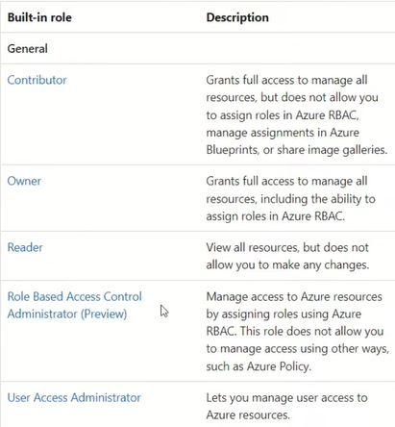
Roles, Administrative Units, and Privileged Identity Management (PIM)
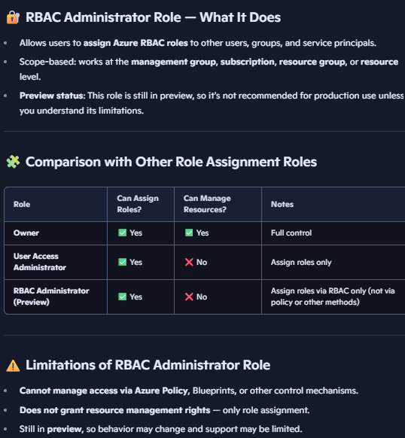
- Entra ID has a rich set of built-in roles and supports custom roles (up to 100 per tenant).
- Roles are assigned to users or special security groups, usually scoped to the entire tenant. To assign roles to other users, a user must have the Owner or User Access Administrator or RBAC administrator role on the resource.
- Administrative Units (AUs) allow scoping role assignments to subsets of users, devices, or groups (e.g., by office or department).
- Restricted Management Administrative Units provide additional protection by isolating critical user/device management from tenant-wide admins.
- Privileged Identity Management (PIM) enables just-in-time elevation for roles with:
  - Time-bound access
  - Approval workflows
  - Justification requirements
  - Conditional Access integration
- PIM improves security by reducing standing privileged access.

Service Principals, Managed Identities, and Device Identities
- Service Principals represent applications or automations and authenticate via secrets, certificates, or federated tokens (e.g., GitHub Actions).
- Managed Identities are special service principals automatically managed by Azure for resources to authenticate without secrets.
- Devices can be:
  - Registered (known to tenant, e.g., BYOD)
  - Joined (corporate-owned, full Entra authentication)
  - Hybrid joined (registered to on-prem AD and Entra)

External Identities and Collaboration
- Business-to-Business (B2B) allows external partners to access company resources using their own identities (federated or social accounts), minimizing password management overhead.
- External Identities supports a wide range of identity providers (Microsoft, Google, Facebook, onetime passcodes, custom providers).
- Business-to-Customer (B2C) or External ID tenants provide customer identity and access management with extensive customization, supporting social logins and local accounts.
- Cross-tenant access and conditional access policies enable granular trust and security controls for external users.

Identity Governance Features
- Access Reviews help organizations periodically validate users’ group memberships, role assignments, and application access to prevent permission creep.
- Entitlement Management enables automation of access lifecycle through access packages and workflows for joiner, mover, and leaver scenarios.
- Lifecycle workflows automate user onboarding/offboarding, group membership changes, and temporary access provisioning.

New Features: Secure Service Edge (SSE)
- Entra integrates with Secure Service Edge technology for:
  - Private Access: Secure seamless access to private network applications via connectors and client agents.
  - Internet Access: Policy-based control and inspection of internet traffic, including TLS inspection, URL filtering, and category-based access.
- Supports Continuous Access Evaluation for near real-time token revocation and session control.

Active Directory in Azure
- Options for using AD in Azure:
  - Azure AD Domain Services (AAD DS): Managed domain controllers for legacy applications needing Kerberos/NTLM authentication, with limited schema control.
  - Extend on-prem AD to Azure: Deploy domain controllers in Azure virtual networks with proper connectivity and DNS.
- Azure VMs can be auto-joined to domains using extensions with secure credential storage (e.g., Azure Key Vault).

Licensing Overview
License Type | Features Included | Notes
Free | Basic identity and access management | Limited capabilities
Enterprise P1 | Full Azure AD capabilities, Conditional Access | Recommended minimum for most orgs
Enterprise P2 | Identity Protection, Privileged Identity Management, Access Reviews | Adds governance and risk features
Entra Suite | Builds on P1, adds private access, verified ID, extended governance | Best for advanced scenarios and security
Azure account - The identity used to sign in to Azure (usually a Microsoft account or work/school account)

